DASHBOARDS 1: Power bi Dashboard.

https://github.com/komaljain1099/Power-bi-Dashboard/blob/main/power%20bi%20(workshop).pbix

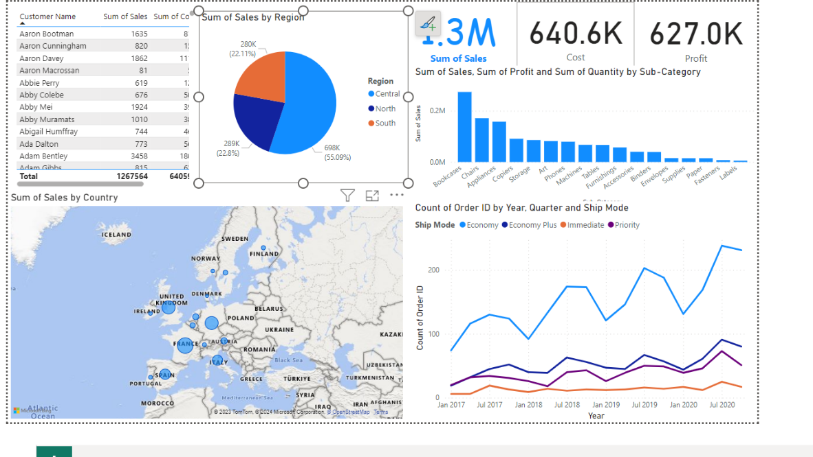

DASHBOARD 2 : Power bi

https://github.com/komaljain1099/power-bi-assignment/blob/main/bi%20presentation.pbix

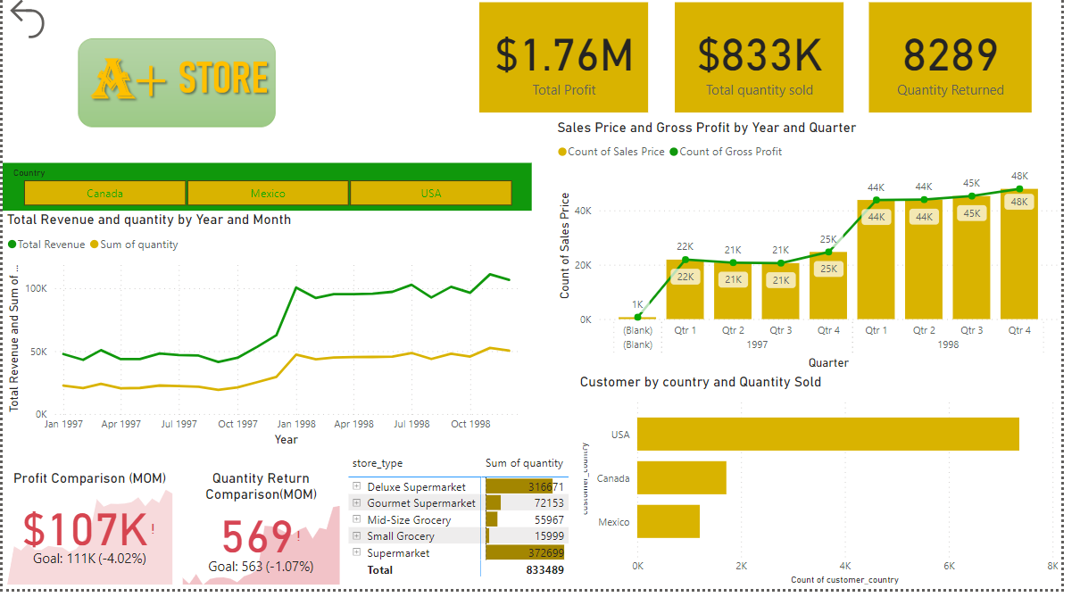

DASHBOARD 3 : Power bi

https://github.com/komaljain1099/Retail_analys---pratice

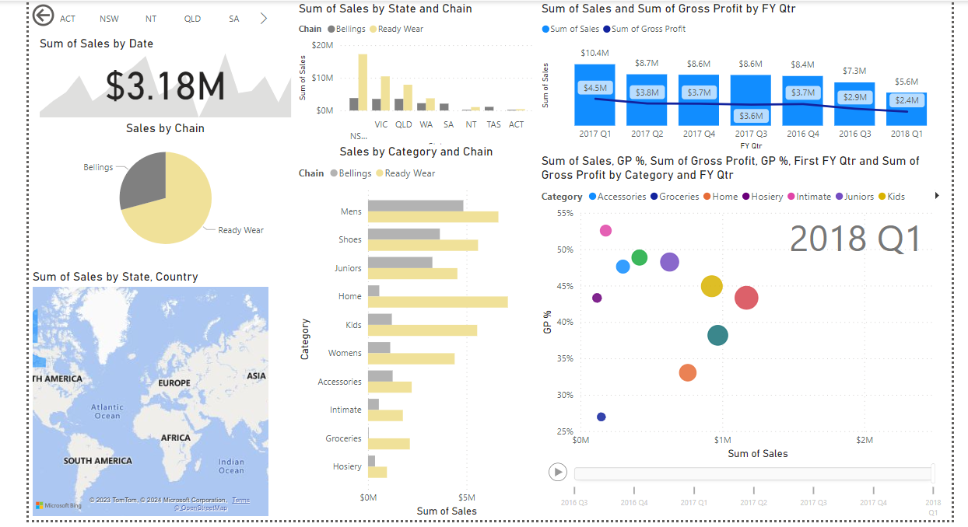

DASHBOARD 4 : Tableau

https://github.com/komaljain1099/tableau-assignment-1/blob/main/Tableau%20Assignment.twb

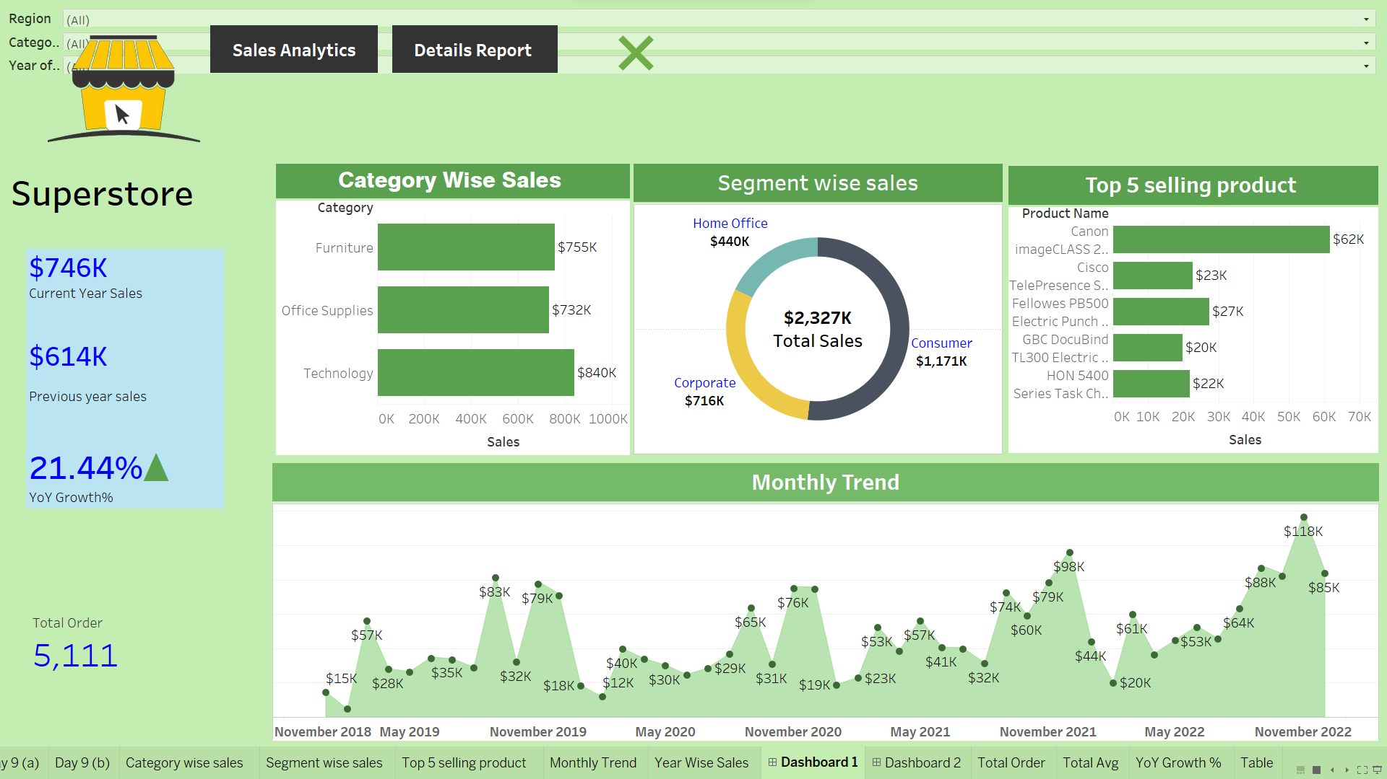

DASHBOARD 5:

https://github.com/komaljain1099/tableau-assignment/blob/main/Tableau%20(TP)_1.twb

s